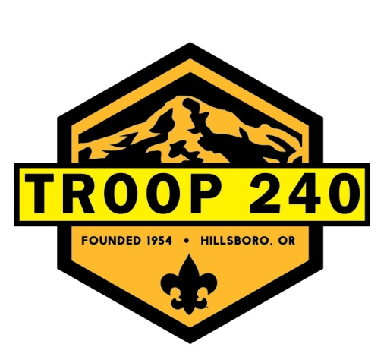
Troop 240 2021-2022 Events

October
Troop Open House, October 16
Field Games – October 18
Halloween Party – October 25

November
Ape Caves day hike, November 13
Cast Iron Cooking with Webelos and AOW, November 15
Scouting for Food, November 27 and December 4

December
Christmas Party, December 6
ALL-Nighter Camping: Movies & Games, December 30

January 2020
Bouldering/Climbing, January 14
Troop Camping (TBD)

February
Scout Sunday February 6
Snow Camping February 11

March
Snow Sports Outing, March 5

April
Patrol Camping
Fin Clip/Orienteering, April 9-10
Crabbing Outing, April 29-30th

May
Camporee, May 2-4
Memorial Day Flags and Ceremonies, May 30

June/July/August
Kayaking Canoe Outing, June 5
Summer Camp at Meriweather, June 26-July 2
Kayaking/Canoeing Camping Trip August 8

http://t240.ScoutLander.com

